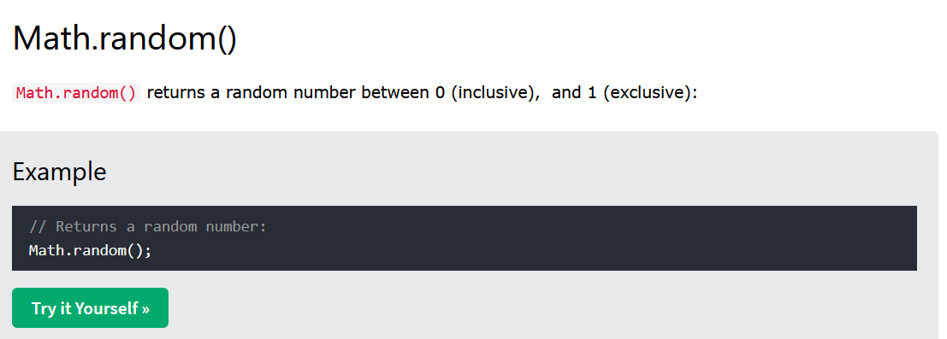

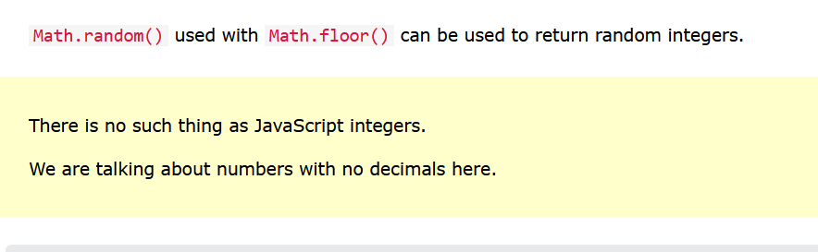

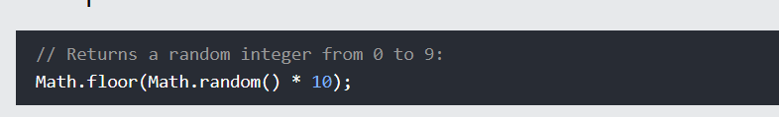

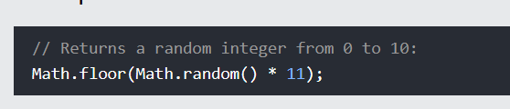

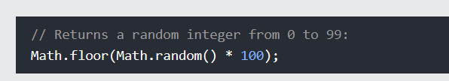

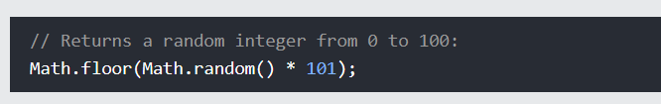

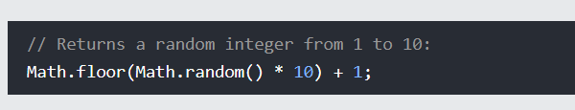

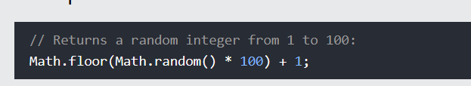

**It’s nice to create a function that will return the random numbers between the minimum and maximum number values**

